# **BUS 5100-93 Term Project Tutorial**

**Los Angeles Earthquake Prediction**

**Using SAC**

**Team 5**

Authors: Jasmine Pesantes, Christian Fierro, Kimberly Cervantes, Sze Wa Ng, Alejandro Ortiz Cazares

Professor: Jongwook Woo

**Spring Semester 2025**

**Helpful Links:**

<https://github.com/cfier001/Earthquake-data.git>

<https://www.kaggle.com/datasets/batuhankalem/los-angeles-earthquake-dataset/data>

**Objective**: Data Engineering exercise to acquire, transform, and model data for data analysis in SAP Analytics Cloud for predicting Los Angeles earthquakes.

**Logging on to SAP Analytics Cloud:**

1. Open a web browser and go to SAP Analytics Cloud (SAC): <https://higher> education.us10.sapanalytics.cloud/

2. Log in SAP Analytics Cloud (SAC)

**Steps to follow to recreate visuals:**

On the left hand side of the screen select the Modeler Icon. Next, click on Create New Model.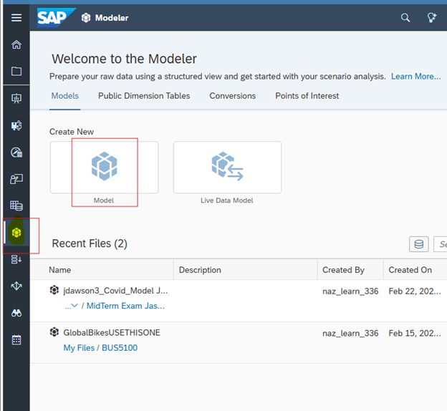

A pop-up screen to Create Model will appear, select the blue text on the bottom, “Want to create a classic model (accounts only) instead?

Select the default “Start with data” and hit Next.

Select “Dataset” as the data source

When “My Files” pops up, select the shared file, “Team 5 Final Project”.

Select the dataset “InstructionsLosAngeles_Earthquake_Dataset to open it

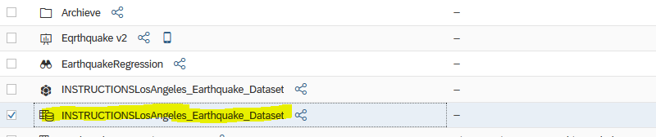

Once the dataset is open, go to SAP’s left menu and click on “Modeler” to create a new Model.

**On the left side menu, click on “Modeler”**

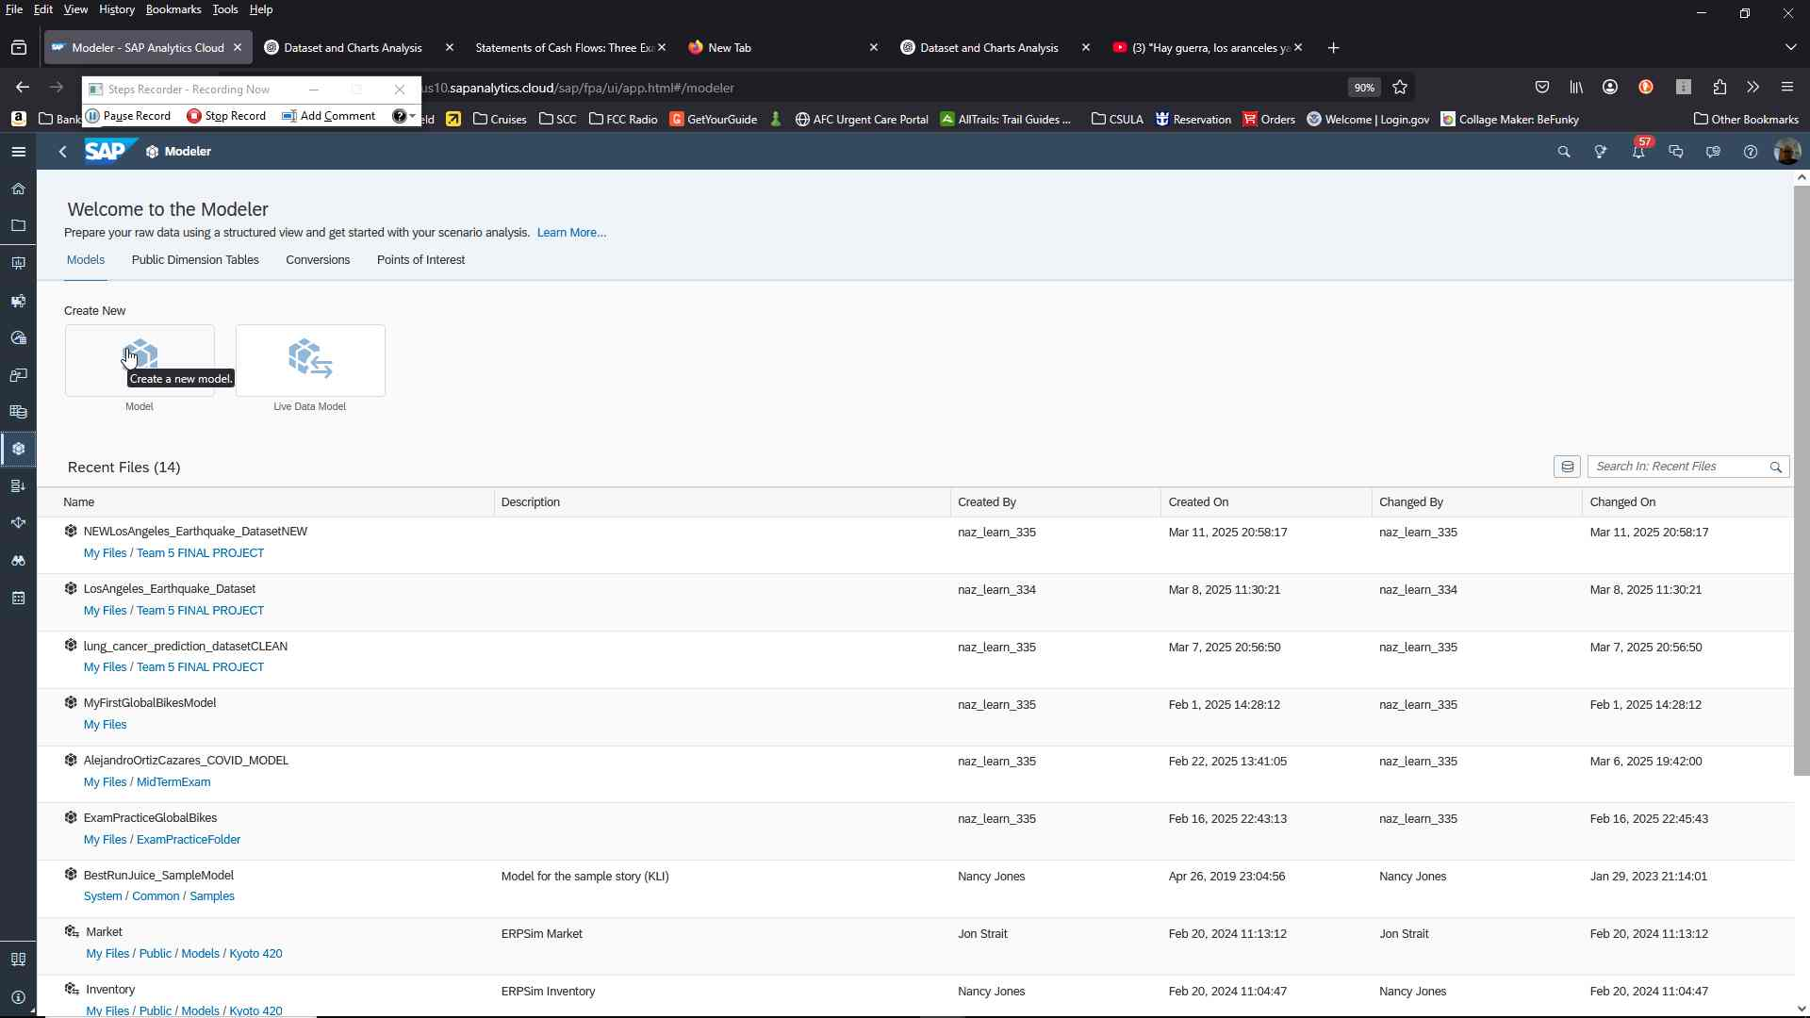

**In the modeler window, 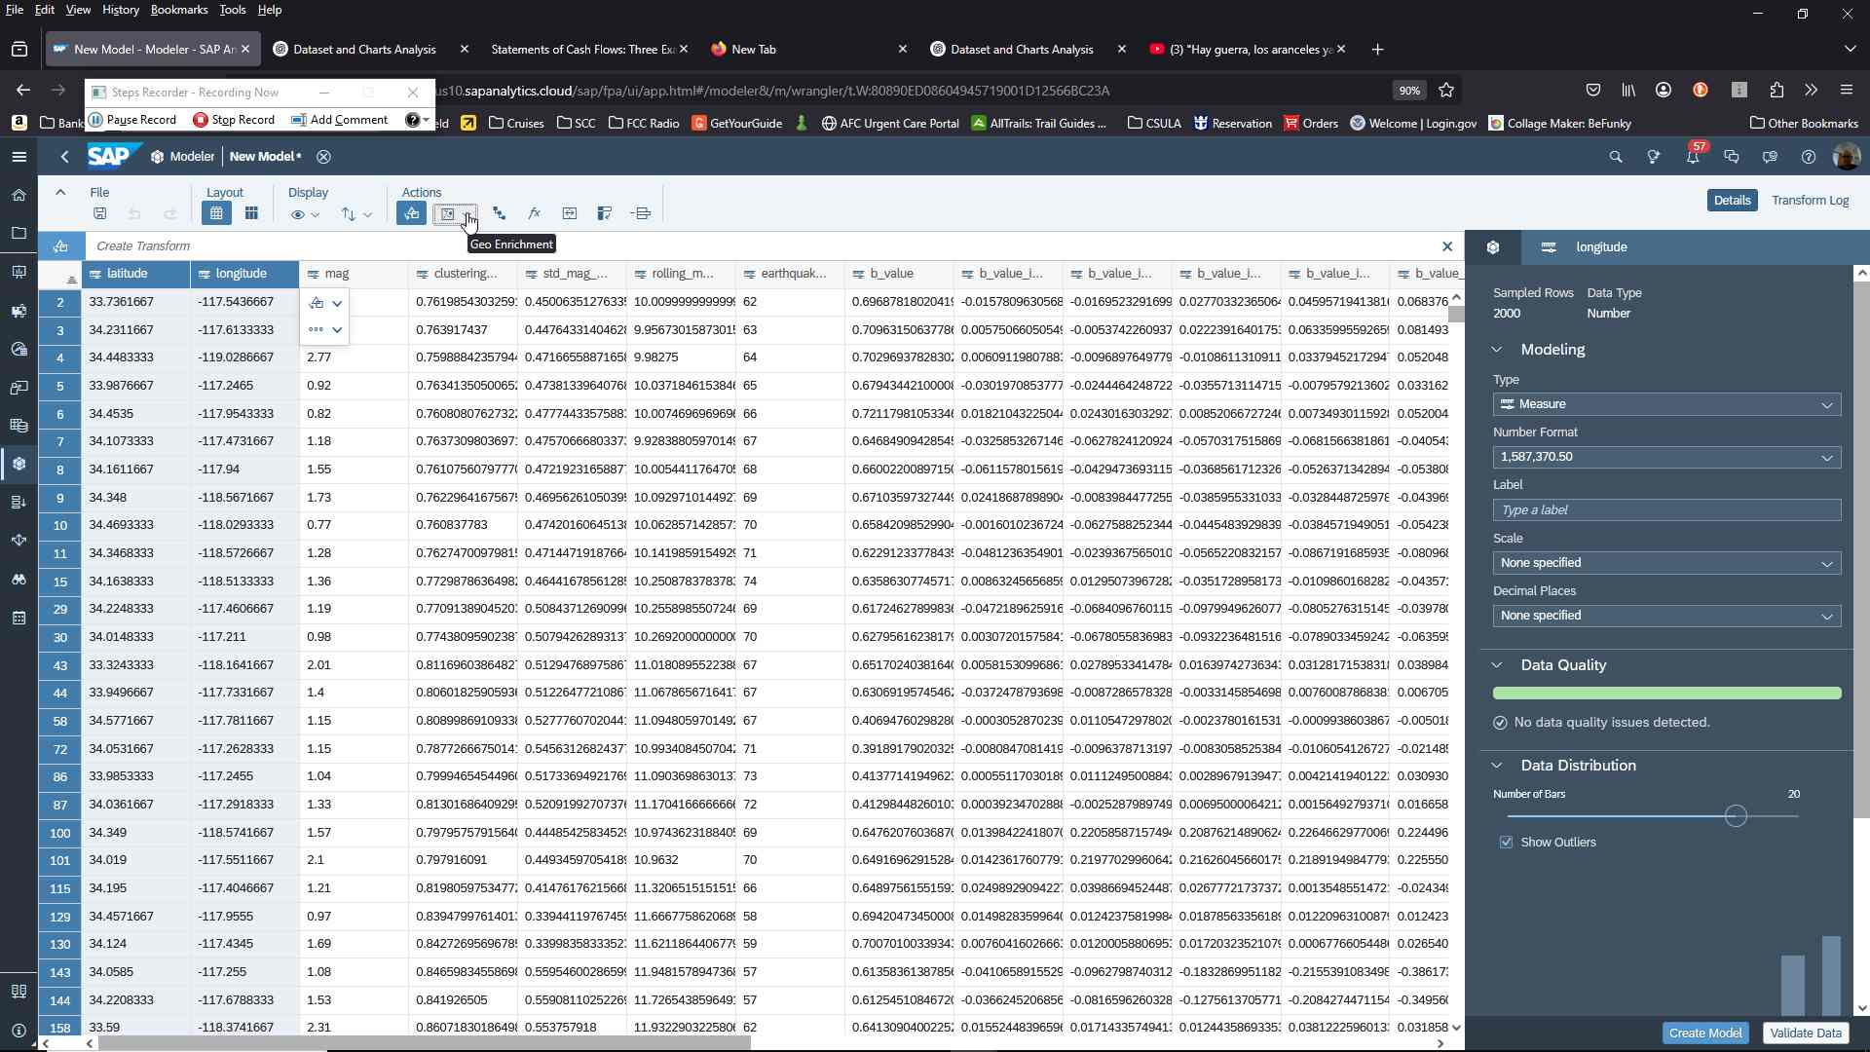using Ctrl + Click select latitude and longitude and then under the actions button select Geo Enrichment” to select “coordinates”.**

**Type your dimension the name “Location” and click “Create” Ensure longitude and latitude are selected in the “coordinates” section.**

**A new column with the location dimension will be created in the Model created**

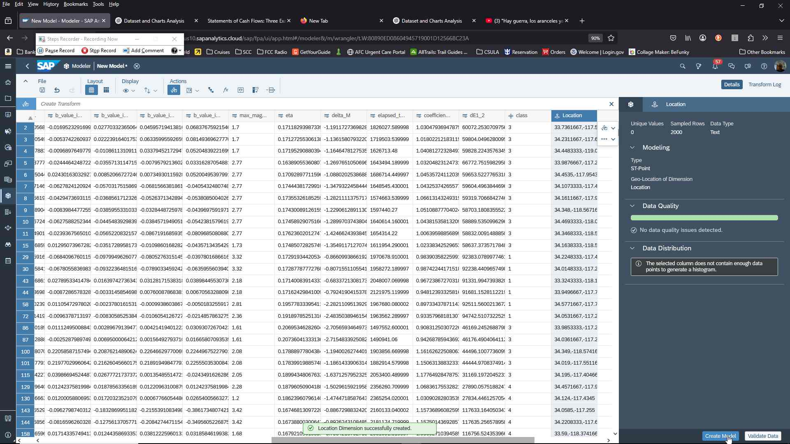

**Select Hierarchy icon under actions:**

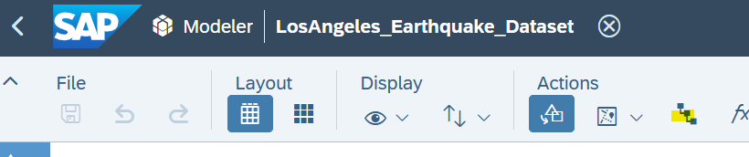

**Insert Mag Hierarchy by + to select column as below:**

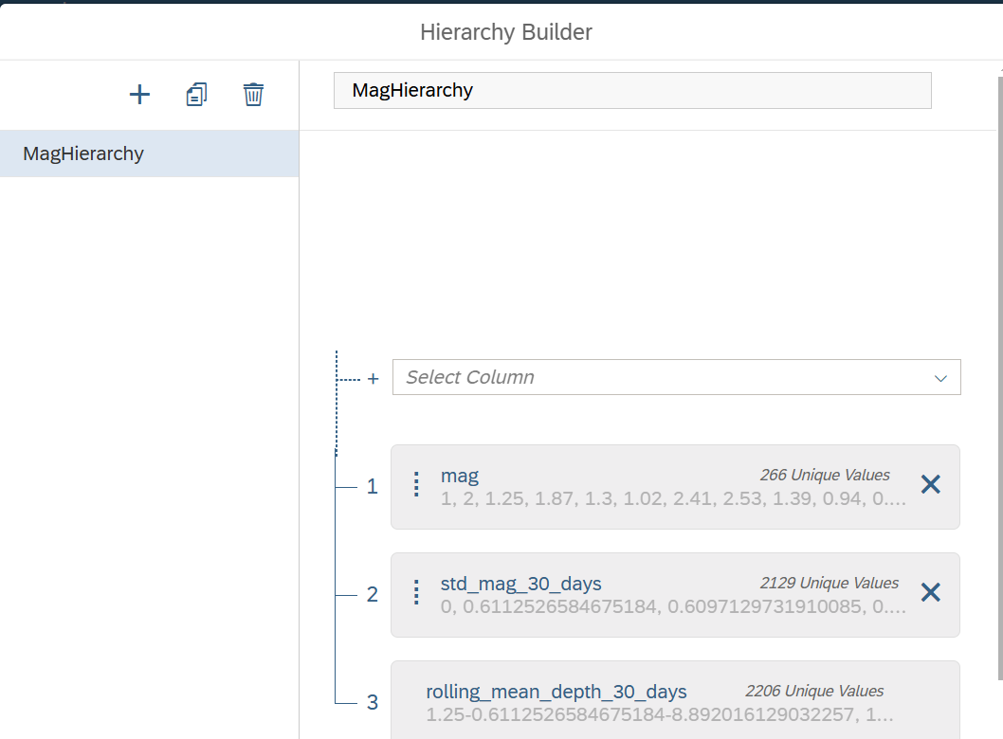

**Create and save your Model in the Team5Final folder.**

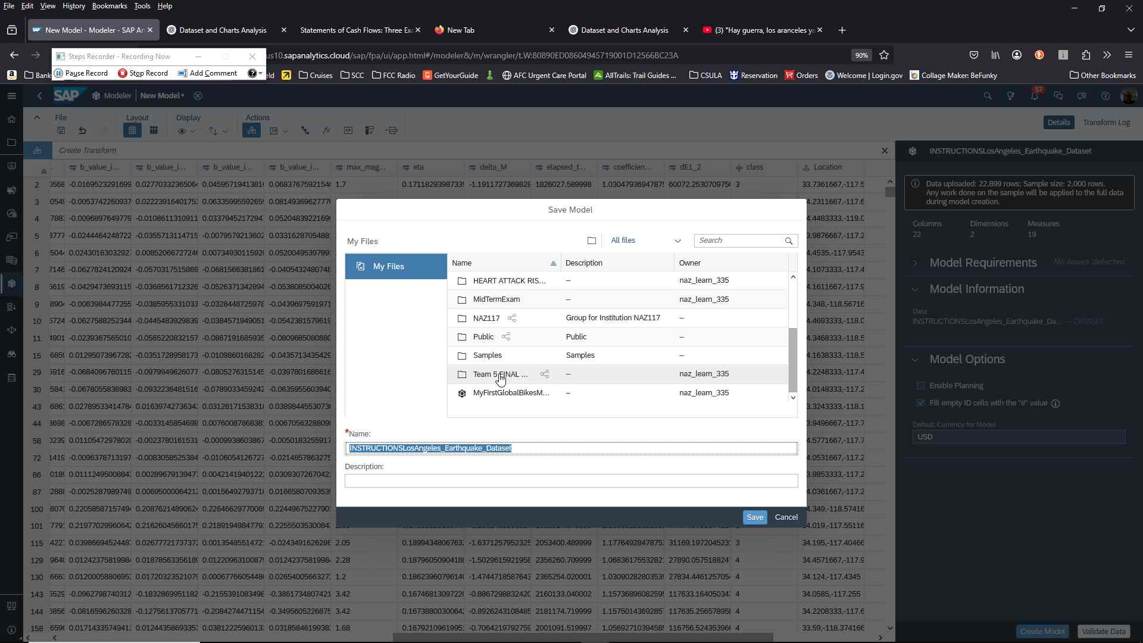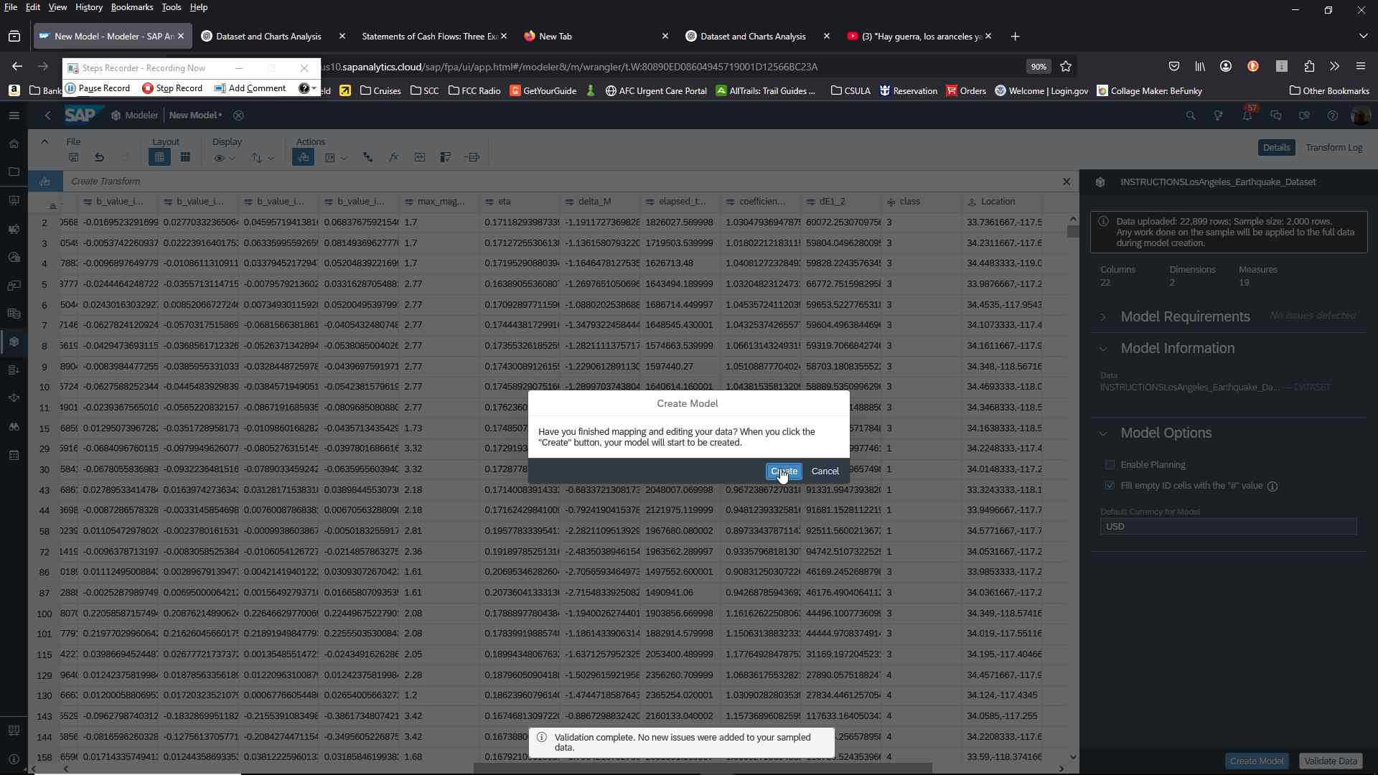

**On the left hand menu, go to “STORIES” to create a Responsive Story. Select Classic Design**

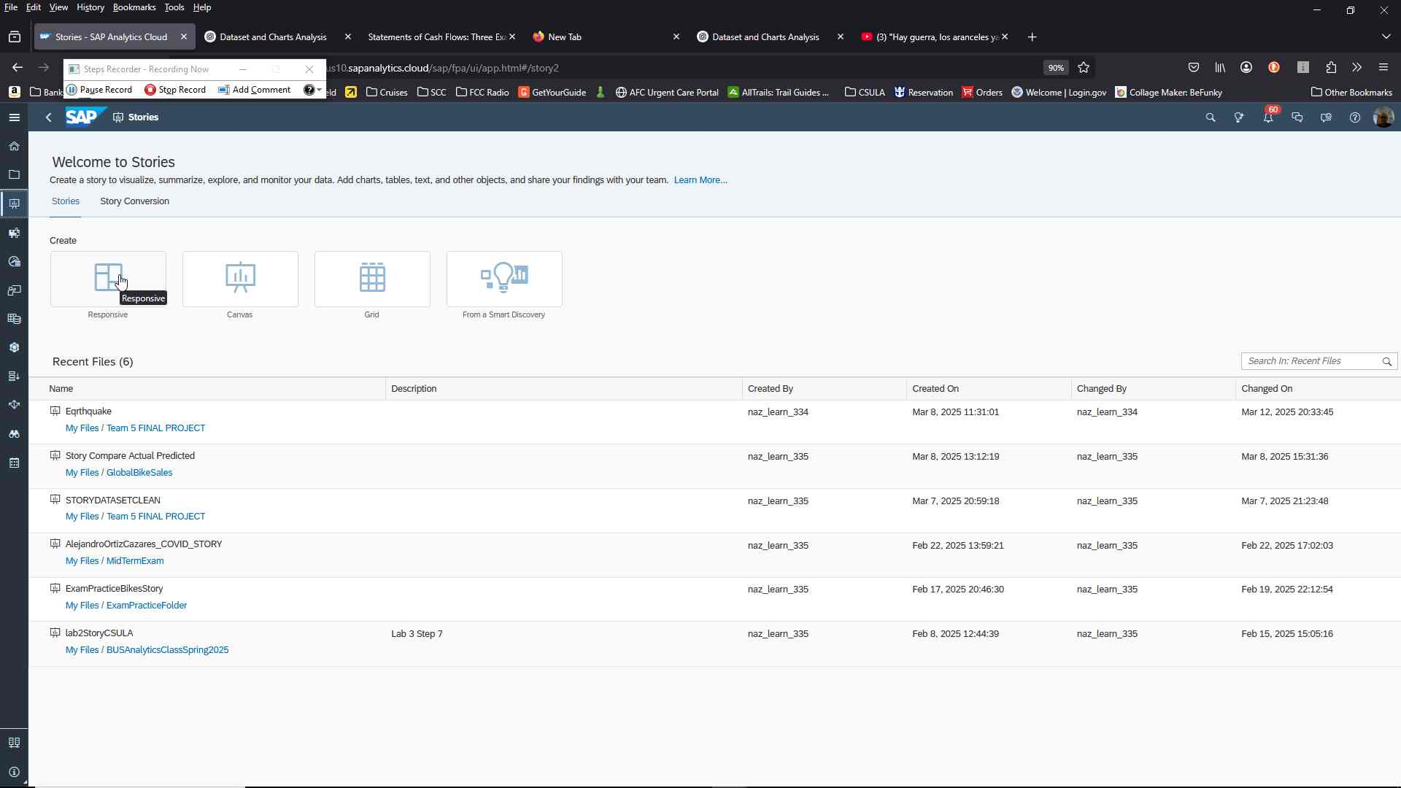

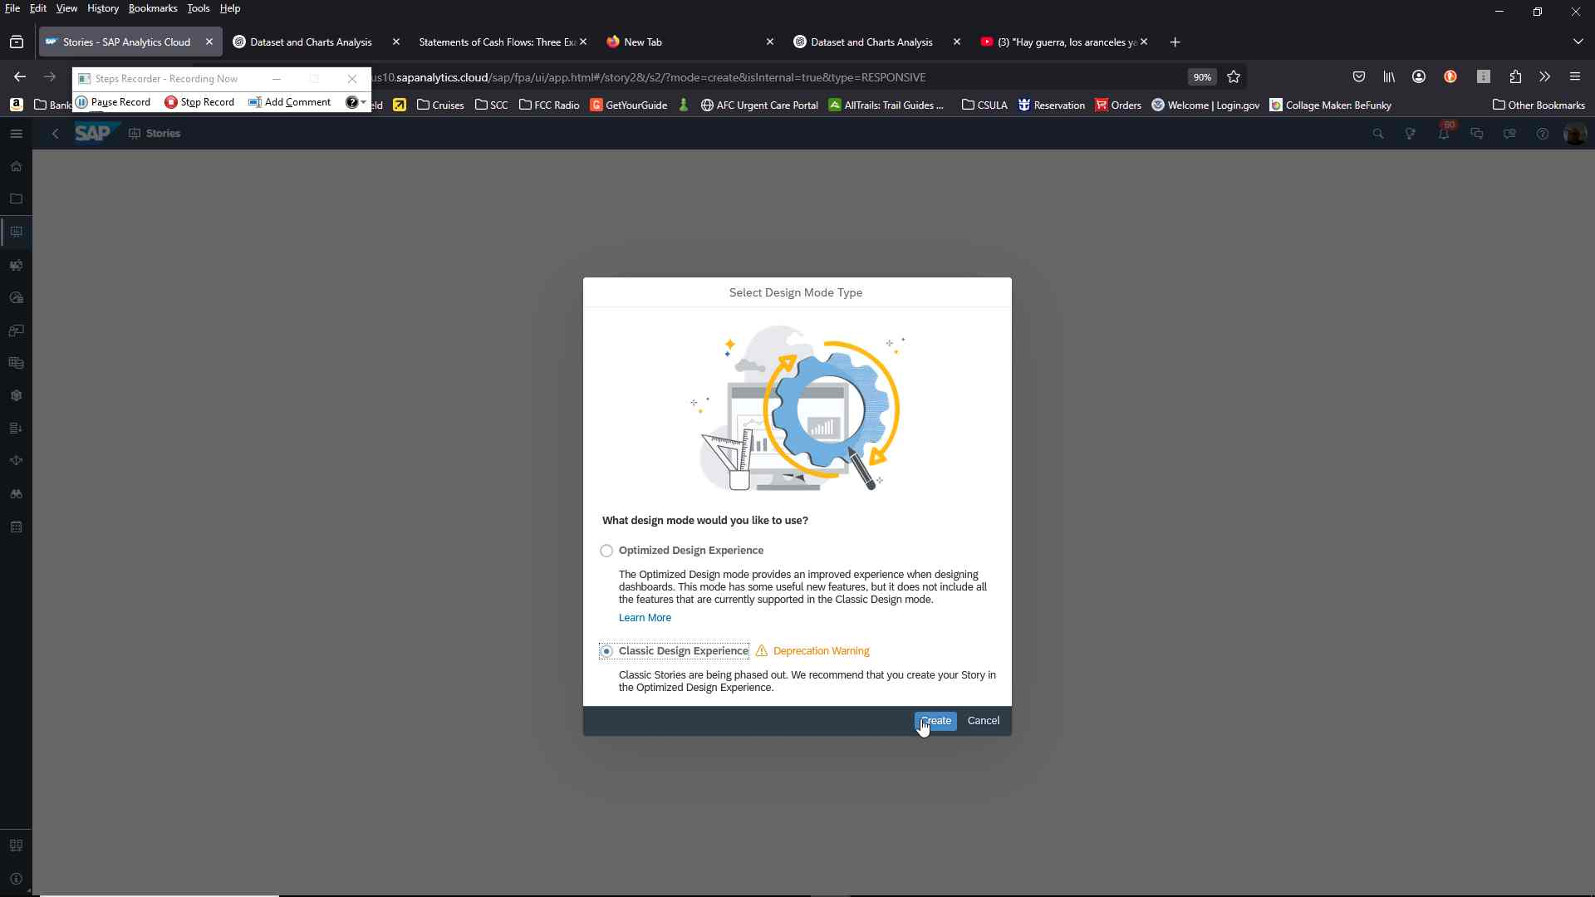

**On the top menu click on “Insert” to create a GeoMap**

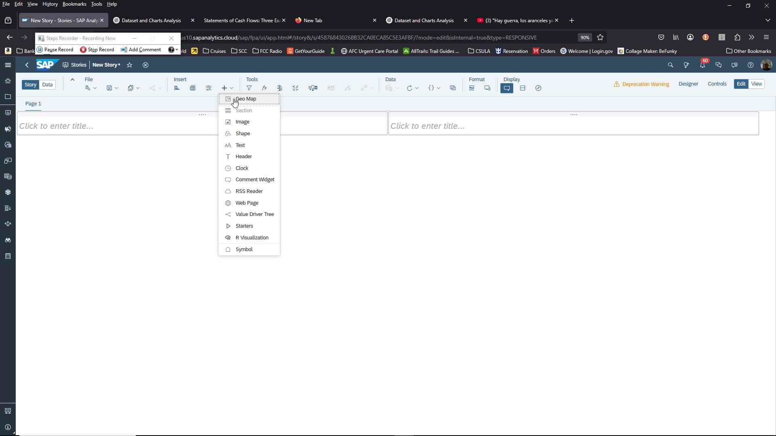

**Select Content layers, “Bubble Layer” and add dimensions.**

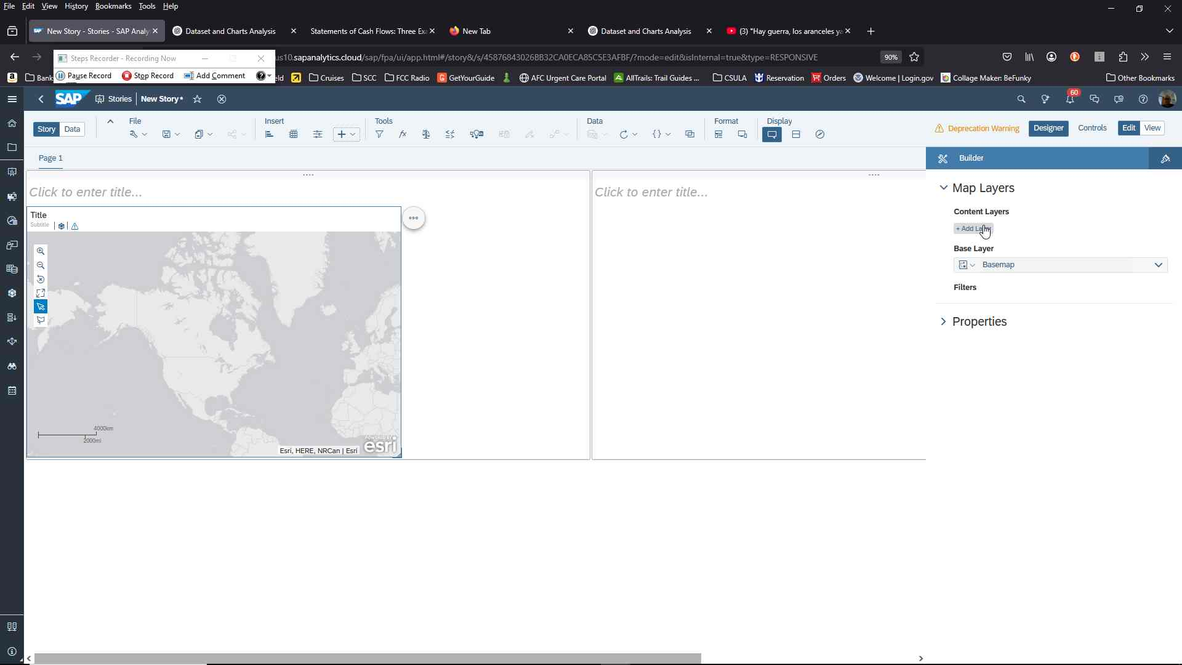

**Conditional:** Ensure your Model has been selected under Data Source.

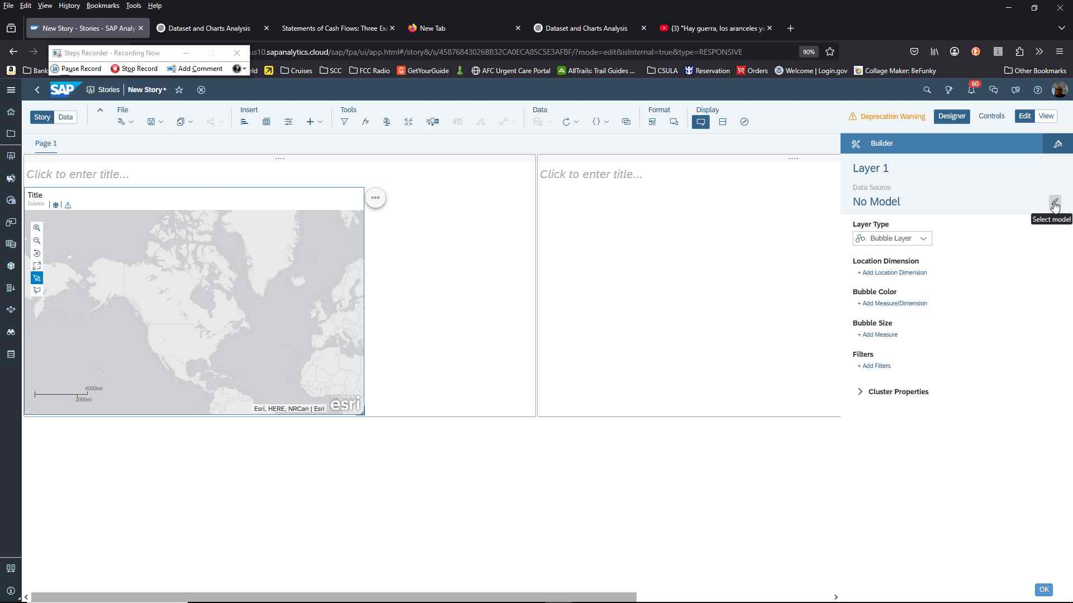

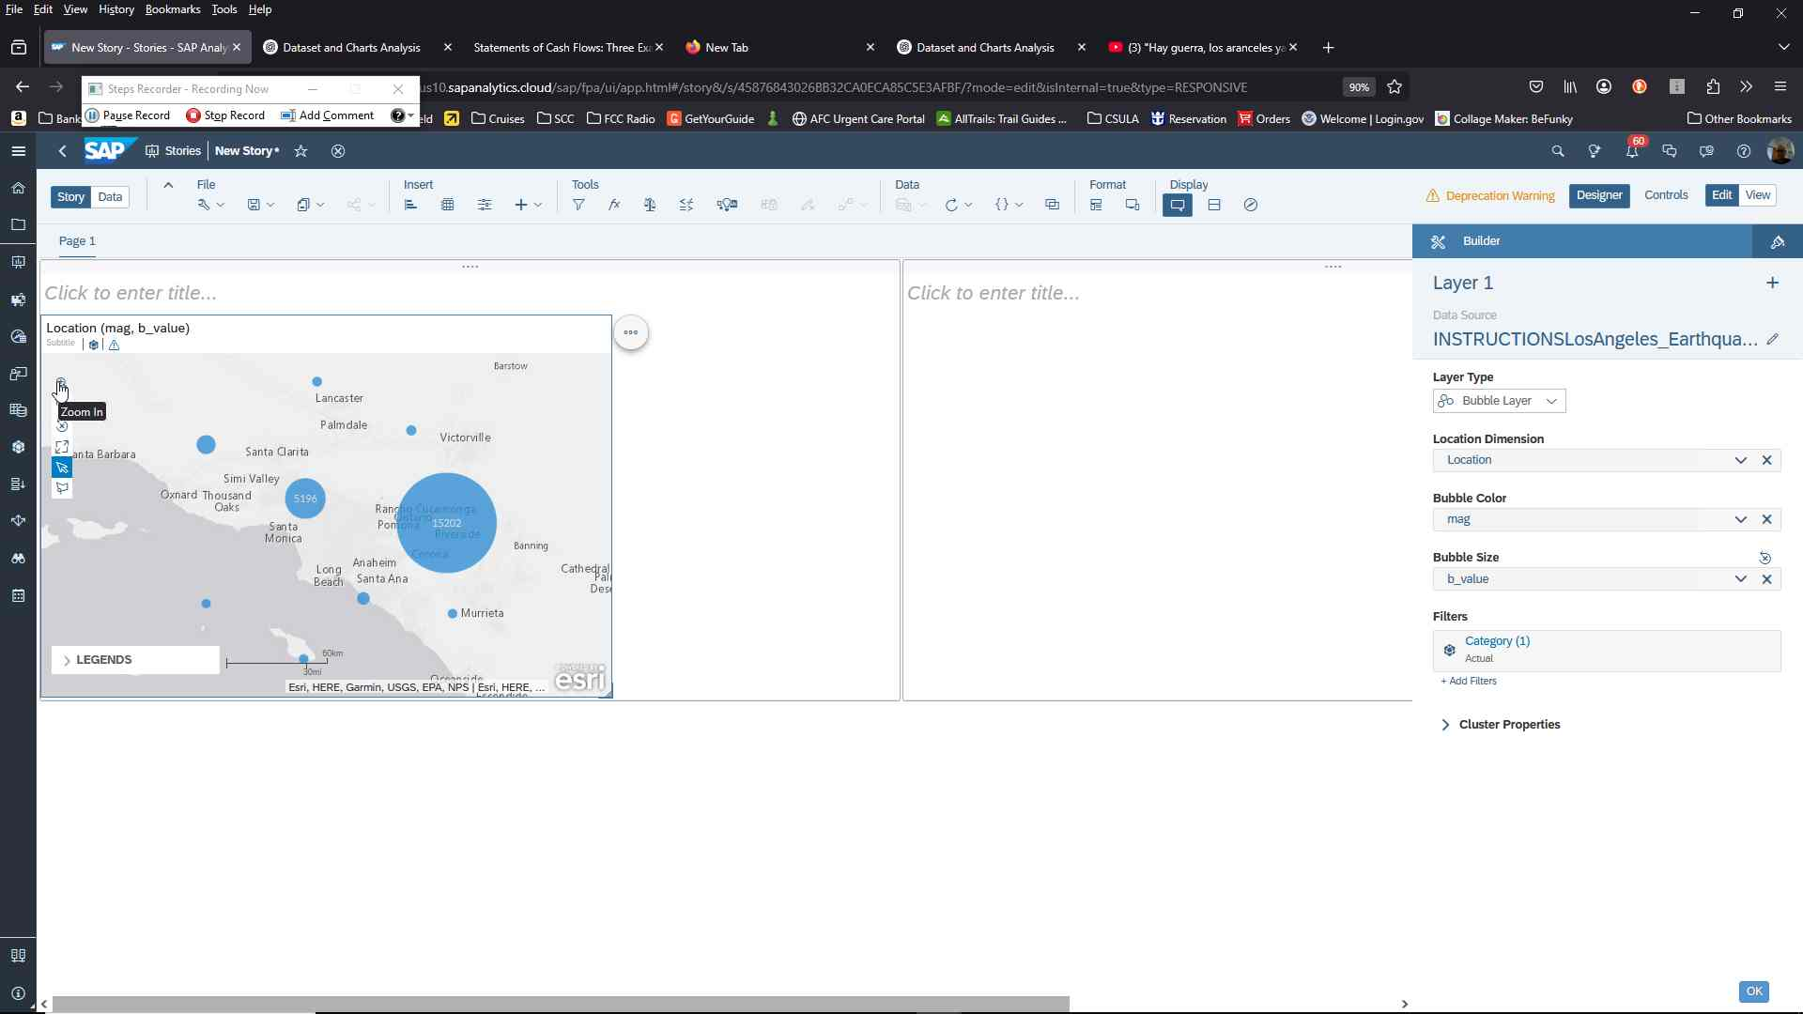**Select**

Location Dimension: Location

Bubble: mag

Bubble Size: b_value

As needed use the map’s zoom controls for better accuracy.

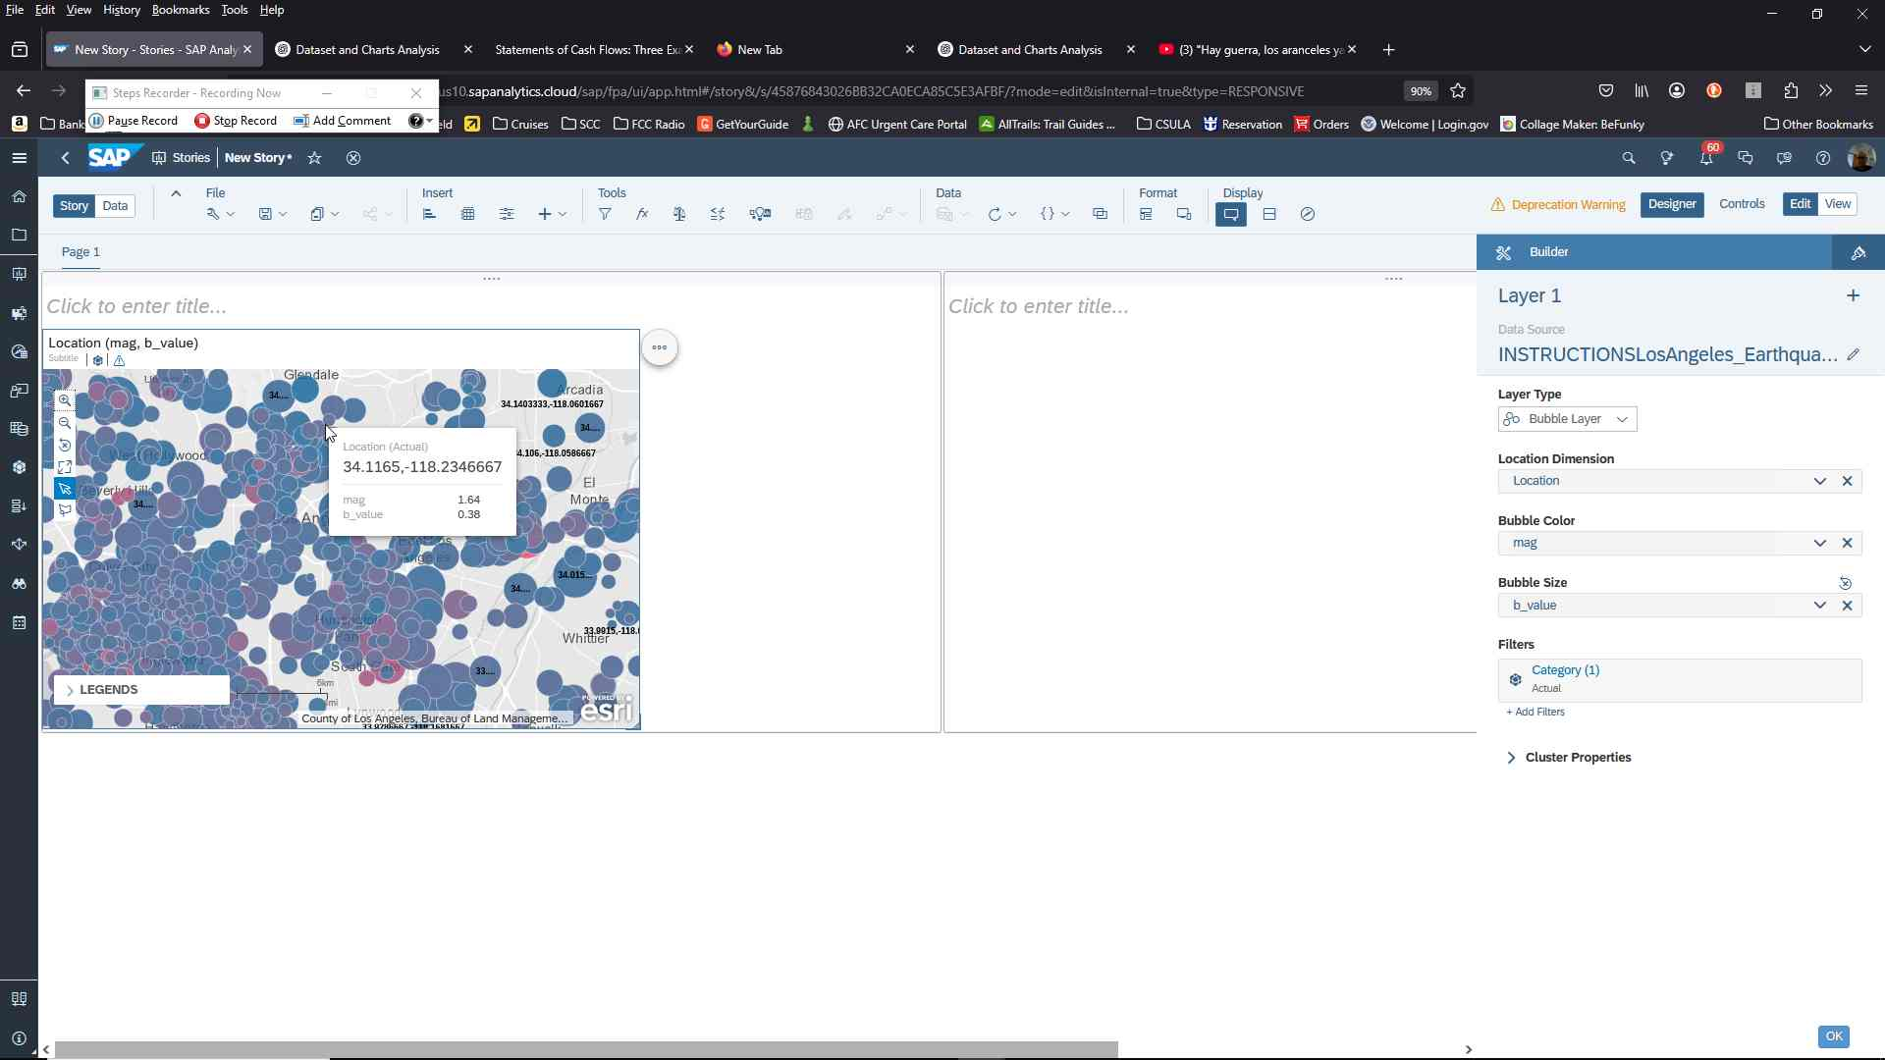

**On the left side menu, click on “Modeler”**

**Chart 2**

**Step 1:**

Add Responsive page

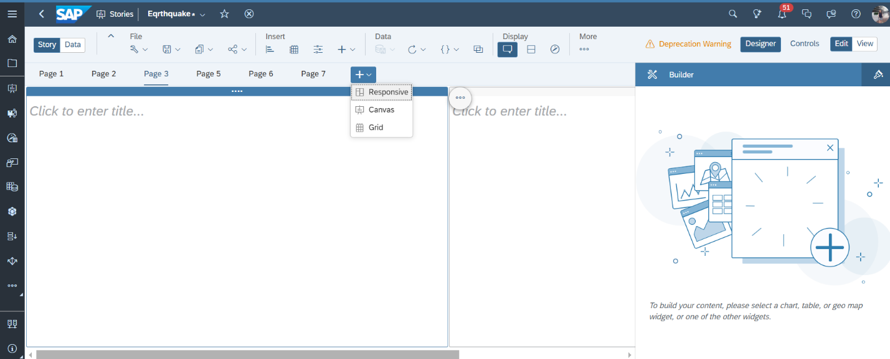

**Step 2:**

Insert Chart and select comparison as chart structure

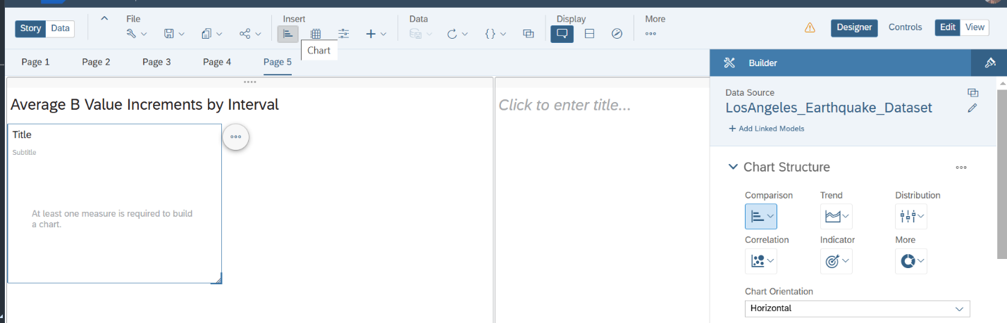

**Step 3:**

**Select Measures** b_value_increment_i_i2, b_value_increment_i2_i4, b_value_increment_i6_i8, b_value_increment_i8_i10

Select class as **Dimensions**

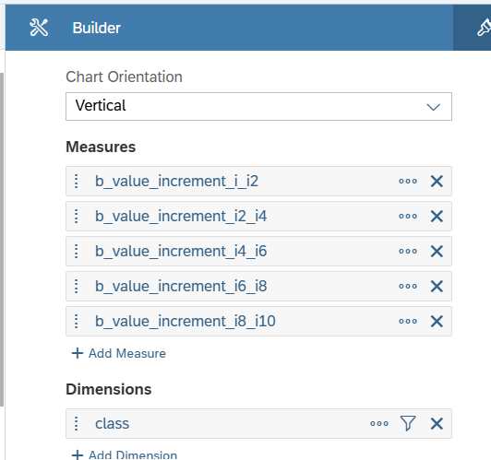

**Step 4:**

Double click on header and rename the chart to “Average B Value Increments by Class”

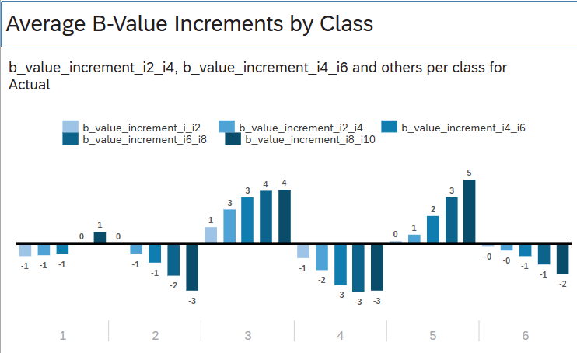

**Chart 3**

**Step 1:**

Add Responsive page



**Step 2:**

Insert Chart and select Line Trend

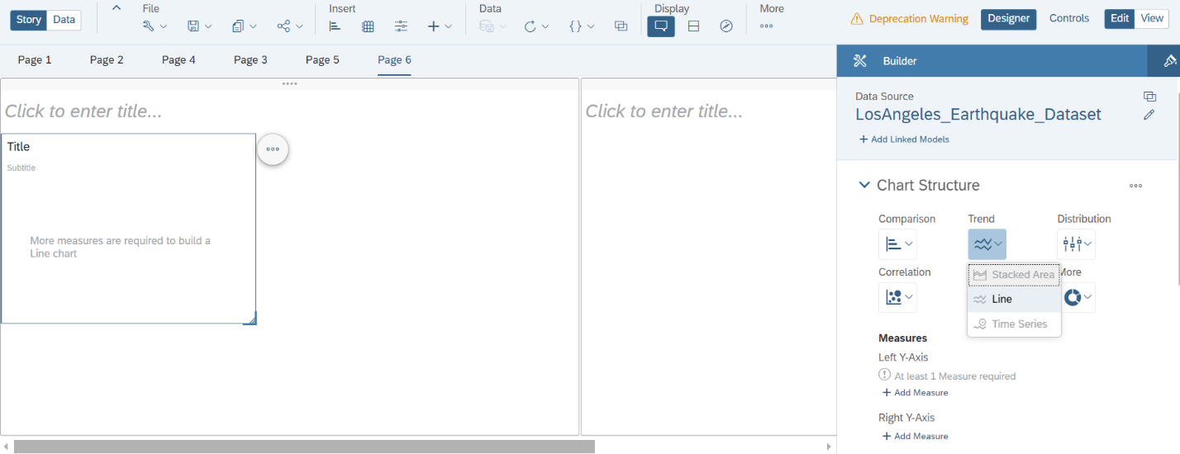

**Step 3:**

Select max_mag_last_week as the Left Y-Axis

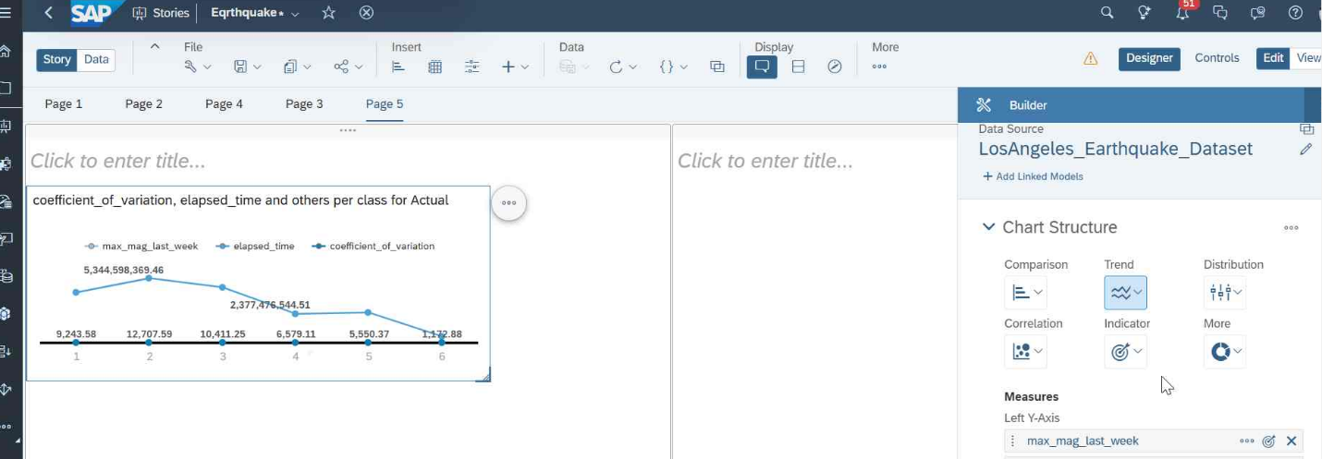

**Step 4:**

Select elapsed_time and coefficient_of_variation as the Right Y-Axis, select class as Dimensions, and max_mag_last_week as color

Configure the Chart Structure as below:

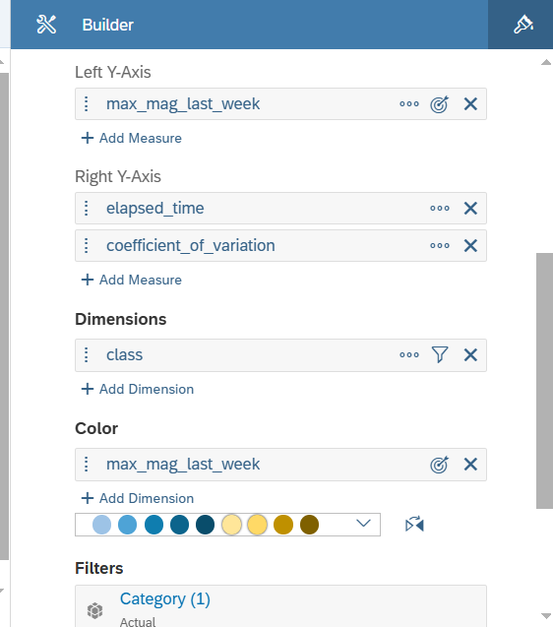

**Step 5:**

Double click on header and rename title as “Earthquake Pattern”

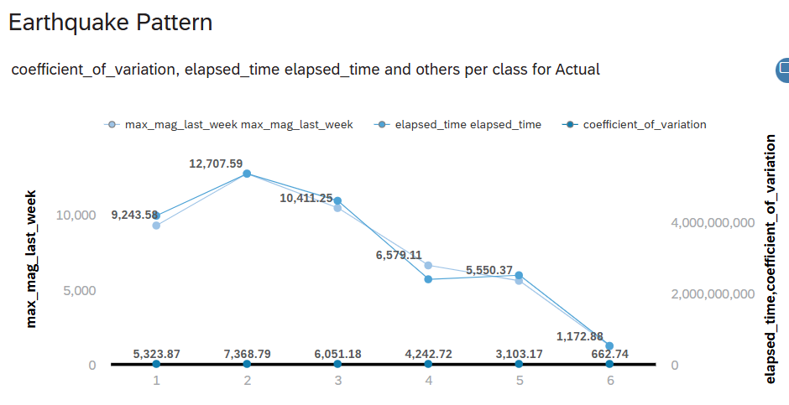

**Chart 4**

**Step 1:**

Add Responsive page



**Step 2:**

Insert Geo Map 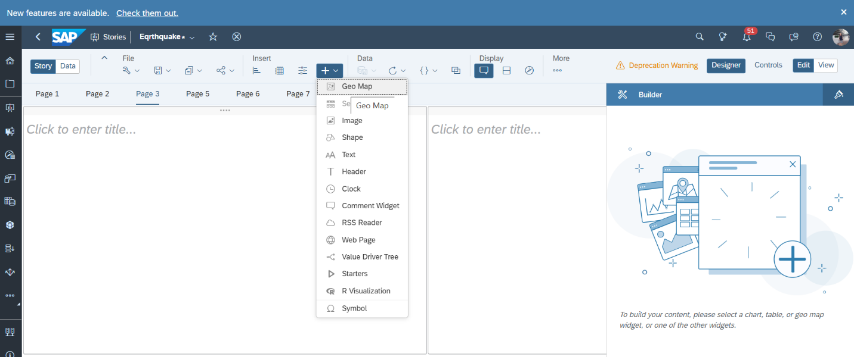

**Step 3:**

Select Add Layer under **Content Layers**

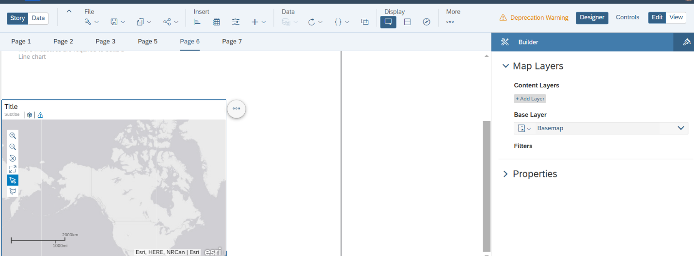

**Step 4:**

Select Choropleth/ Drill Layer as **Layer Type**; and select Choropleth as the **Style**

Select Location as the **Location Dimension**

Choose elapsed_time as the **Choropleth Color**

**Layer 1 as below illustrated:**

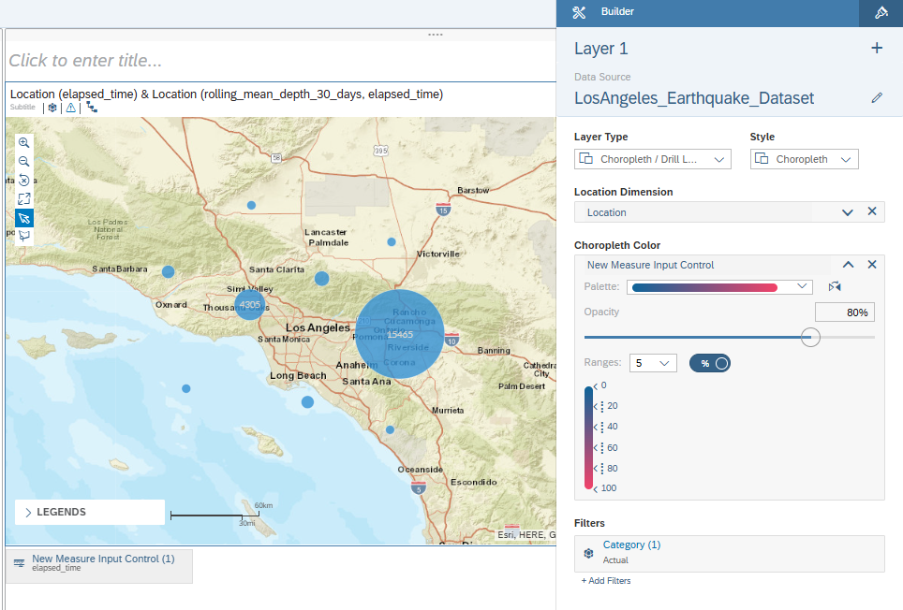

**Step 5:**

Click on Add Layer to create Layer 2

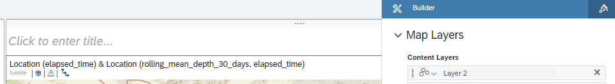

**Step 6:**

A) Select Bubble Layer as the **Layer Type**

B) Select Location as the **Location Dimension**

C) Choose rolling_mean_depth_30_days as the **Bubble Color**

D) Opt for earthquake_last_30_days as the **Bubble Size**

**Layer 2 as below illustrated:**

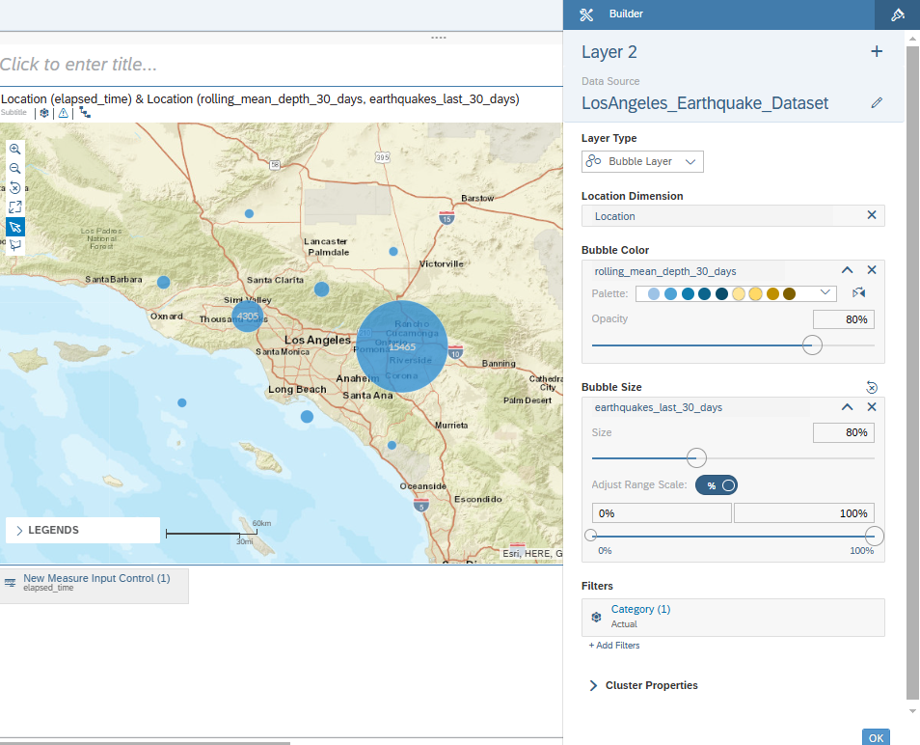

**Step 7:**

Zoom in or out to navigator the location of earthquakes

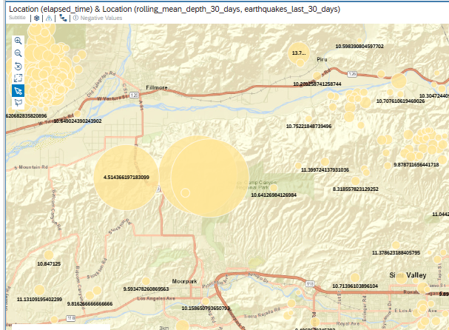

Graph as below:

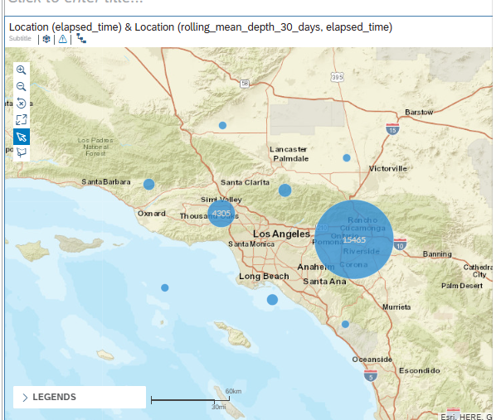

**Regression Forecast Scenario**

**Step 1:** Select Regression

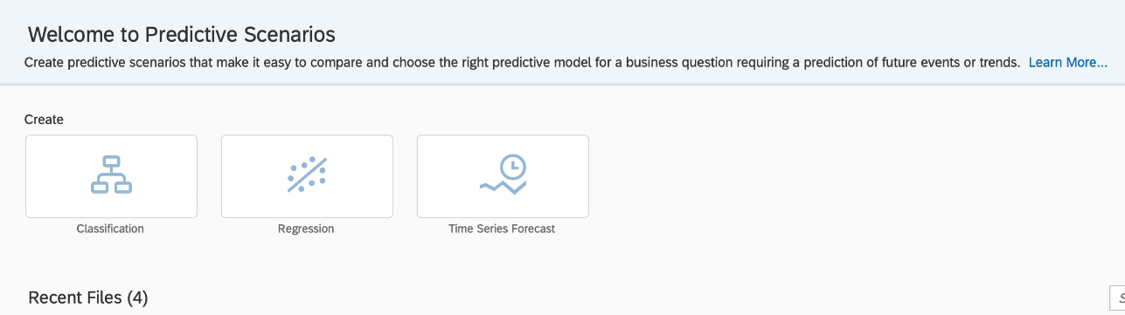

**Step 2:** Select Data File

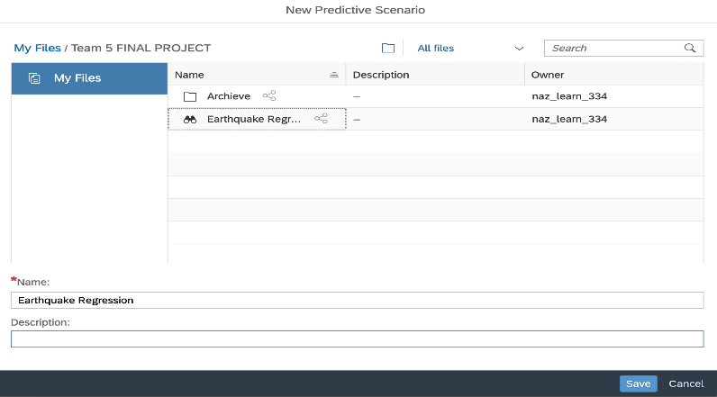

**Step 3:** Choose Training Data Source

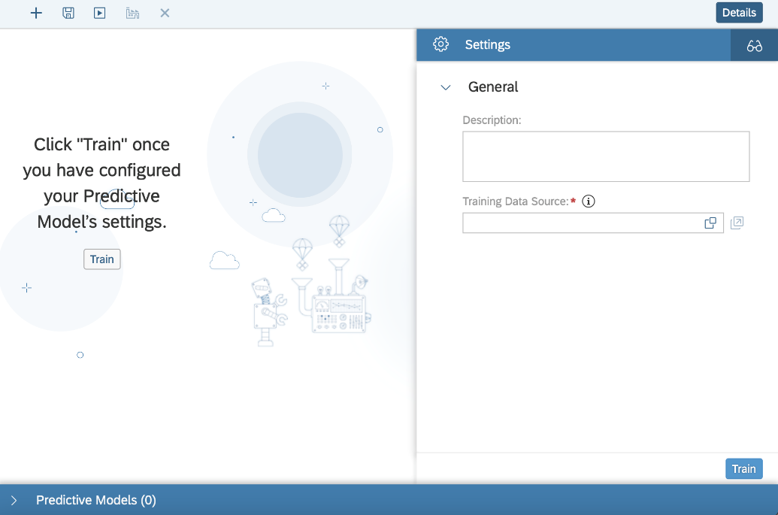

**Step 4:** Add Elapse Time to **Target**

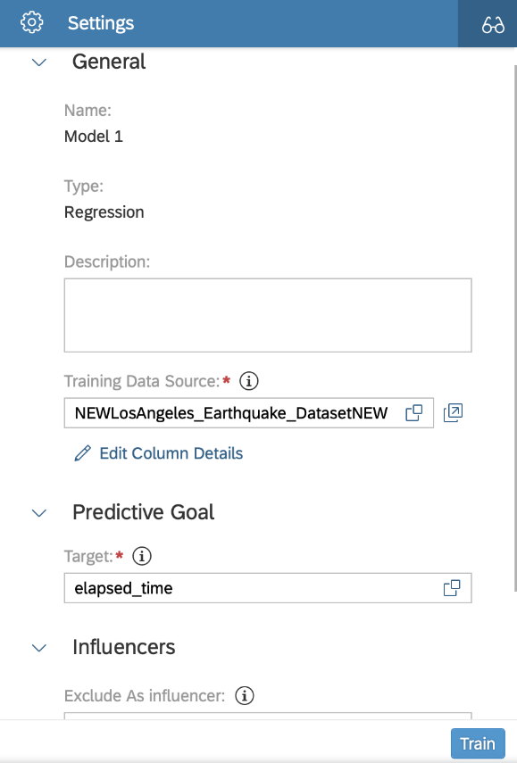

**Step 5:**  Select Train and data populates

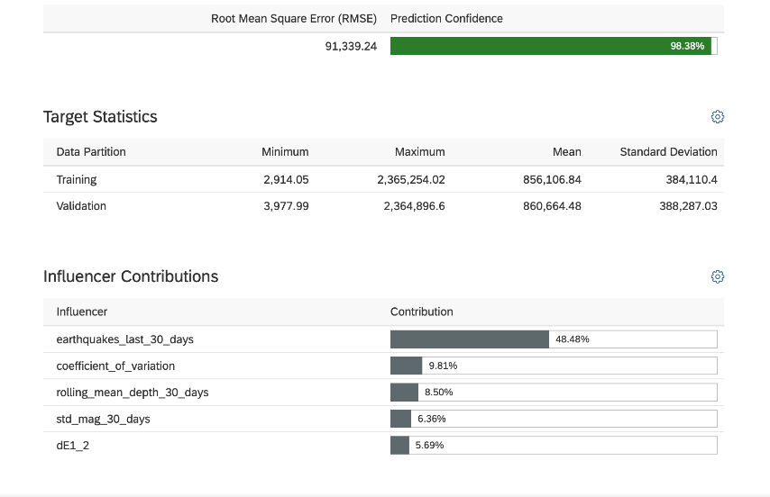

**Step 6:** Scroll down for additional information

